Project On Tableau



**( Department of Information Technology)**

**Maharaja Surajmal Institute of technology**

Submitted by :- Rohit kapoor

**DOMAIN BACKGROUND**

We Wash You Sleep is laundry pickup services start up. They go door by door to sell their laundry services but it is a relatively small company and cannot compete with the big players in the market.

The company’s strategy is to build a vast network in relatively smaller cities so that when a bigger company comes there it need’s not to do everything from the scratch, it can simply buy this company and rebrand it.

We Wash You Sleep already had a strong presence in 140 locations and recently opened in 10 new cities. Additionally the company has two separate regions

**Problem Statement**

We need to identify which of the two sales region is performing better ie. Outperforms the other in two or three metrics:-

1. Average revenue per city
2. Average marketing spend per city(less is better)
3. Average ROMI per city (revenue/ marketing spend)

Identify which of the 10 new locations have the best potential for the company to invest more funds into marketing

**Datasets and inputs**

Two datasets are being considered for this problem the first one is the data gathered by the company it includes the store id, the city they are in and the state that city is located in also it includes information about the region marketing spend and revenue the first ten rows of the dataset are:-

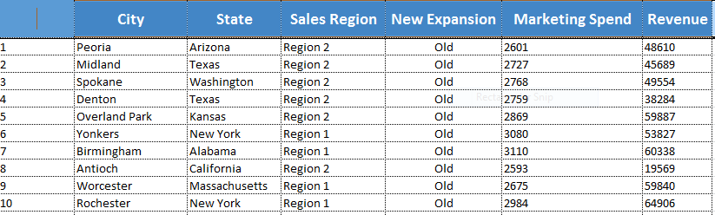

Using this dataset we can identify which of the cities outperforms the other in terms of the marketing spend and the returns that are gathered by the city it would help in solving our problem weather the company should invest more funds into the marketing for the ten new locations

The second data set considered for this project is the data of the population of the various cities of the US, it compares the change in population in the years 2010 and 2015. The first ten rows of the dataset are shown below:-

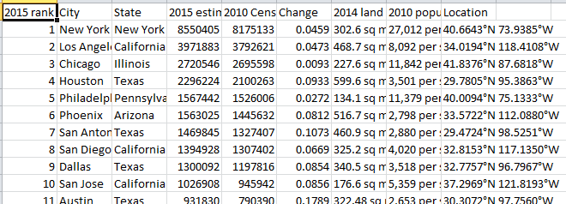

This dataset will help in analyzing how does the population of the cities affects the revenue obtained in a city and is it profitable to invest more marketing spent based upon the population

**Project Design**

* Identification of which region performs better

In order to identify which of the two sales regions performs better we will calculate the average revenue per region, the average marketing spent and also the return on marketing investment (average ROMI for the two regions).

For this we will plot a map in tableau:-

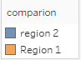

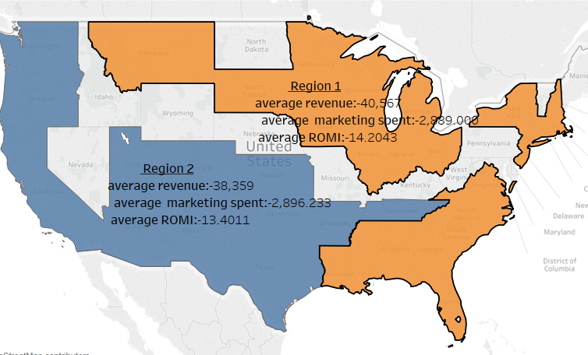

The conclusion drawn from the above visualization is that the region 1 has greater revenue as compared to region 2, the average marketing spent for region 1 is about 2,889 whereas for region 2 the marketing spent is 2896.233 which is much larger that the region2 further the average ROMI for region 1 is greater that the region 2 by 0.8032 dollars

The conclusion from derived from this visualization is that region 1 outperforms region2

* Comparison of the revenue brought by the new cities to the old ones

In order to compare the cities in terms of the revenue brought we will plot them onto a map with size as a medium of comparison

 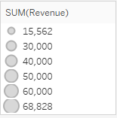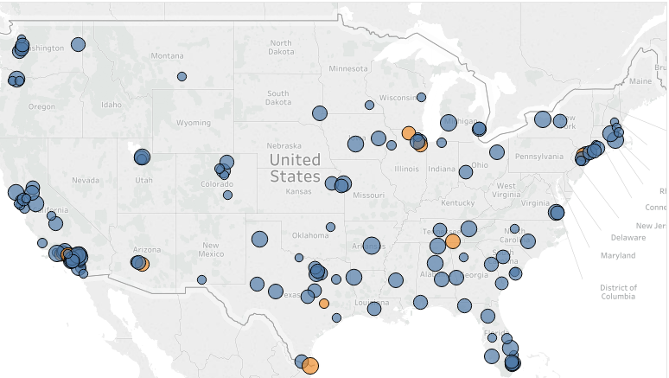

In the above visualization the circles marked in orange show the cities which have been newly established and their current revenue. It is clear from the visualization that the revenue for the new cities is comparable to that of the older cities

For most of the new cities the revenue generated is above the average revenue generation for region 1 and region 2 except for Paterson located in New Jersey which has a revenue of 34,603 and College Station located in Texas with a revenue of 22,457

* Variation of revenue with marketing spend

The revenue obtained by different cities varies with the marketing spend as shown in the visualizations

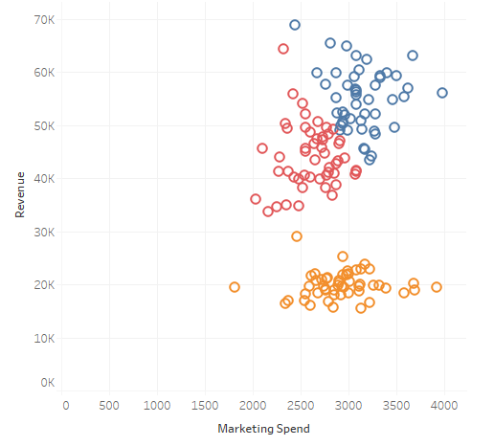 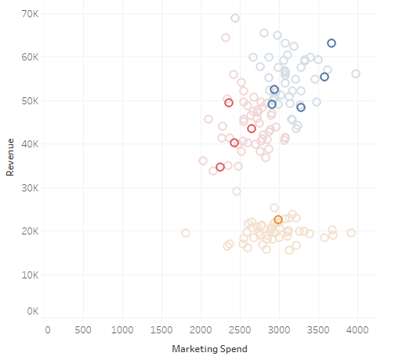 fig(1) fig(2)

From the visualization it is clear that there are three clusters according to revenue and marketing spent the points in the blue cluster are the cities generating the highest revenue but they also have the highest amount of marketing spend while the cities in the blue cluster have slightly revenue and marketing spend and the cities in the orange cluster have a high marketing spend and a very low revenue generation.

Our ten new cities are shown in fig (2) of the visualization among these cities five are in blue cluster, 4 in red and only one city is present in the orange cluster, now to investigate which of the cities are the best locations to invest more money in marketing we will consider, we need to consider another important factor ie the population of the city because the greater is the population the greater will be amount of dirty clothes and hence more services will be required

* Variation of revenue obtained according to population and marketing spend

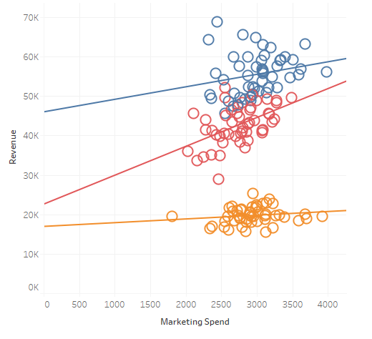 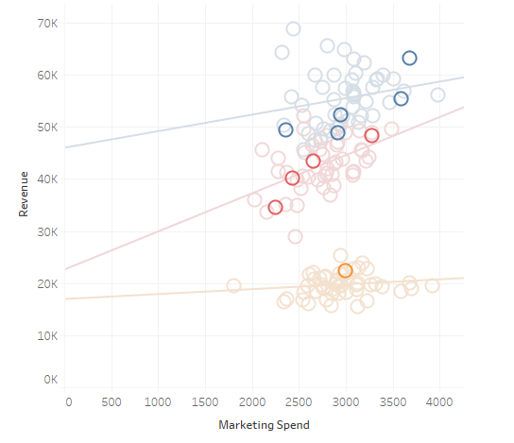

fig(3) fig(4)

In case of the orange cluster the slope of the trend line is 0.94 ie for every dollar spent in marketing only 0.94 cents are returned thus there is no profit in investing in the cities present in the orange cluster

In case of the red cluster the slope of the trend line is 7.32 ie for every dollar invested in marketing the company will make a profit of 6.32 dollars.

While for the blue cluster the slope is 3.17 and the company makes a profit of 2.17 dollars for every dollar spent in marketing.

According to the above analysis the cities in the red cluster are the best locations to invest in marketing. The three cities for the company to invest will thus be New Jersey, California and Illinois

**Conclusion**

According to the analysis region 1 outperforms region 2 in all the three metrics

It has lower average marketing spend, higher average revenue and higher average ROMI

The top three cities that the company should invest into are New Jersey, California and Illinois, it is estimated that these cities will return a revenue of 7.32 dollars per dollar invested in marketing.

**References:-**

1. “Information Dashboard Design Displaying Data for At-glance Monitoring” by Stephen Few
2. “Beautiful Visualization, Looking at Data Through the Eyes Of Experts by Julie Steele Noah Illiinsky”
3. [www.community.tableau.com](http://www.community.tableau.com)
4. [www.Kaggle.com](http://www.Kaggle.com)
5. [www.superdatascience.com/tableau](http://www.superdatascience.com/tableau)
6. [www.census.gov/data/tables/2015/demo/popest/total-cities-and-towns.html](http://www.census.gov/data/tables/2015/demo/popest/total-cities-and-towns.html)
7. [www.worldpopulationreview.com/us-cities/](http://www.worldpopulationreview.com/us-cities/)